Grading guideline (see answer key next to each task number)

PGR111 Databases Exam (2025Fall)
Exam: Individual written home examination.
Duration: 3 weeks (01.12.2025 – 22.12.2025, see WISEflow for exact delivery deadline).
Grading scale: The Norwegian grading system, pass or fail.
Weighting: Passing of the overall assessment.
Support material: All support materials are allowed.

General instruction

This is a 3-week exam, and while there is no strict length or time requirement, you are expected to spend approximately 3-4 full working days during this period on the submission.

It is acceptable to use less time, but you should ensure that your work reflects solid effort, resulting in a well-developed, quality report that demonstrates a thorough understanding of relational databases.
- You should utilize pertinent course materials, and you are welcome to incorporate additional readings and references as well.
- You can either create your own case for database design, allowing you to tailor the scenario to your interests, or you can opt to use the pre-made case NordicX below.
- If you choose to create your own case, you should write detailed description of it by making use of NordicX as a reference to guide the level of detail and structure expected in your description. Also, create other retrieval SQL queries using the same kind of commands and keywords as in Part 2.
- Make sure that you have attempted all the 15 tasks across Part 1 to Part 3 of the exam and clearly separate your answers using part numbers and task numbers.
- Finally, your report should include a PDF document containing text, diagrams, SQL statements, results as screenshots for each retrieval queries (just like you did for the mandatory coursework), along with a separate file featuring a 7-minute video (see Task#15).

Case description for NordicX
NordicX is a hypothetical Scandinavian-inspired small business retail company specializing in high-quality, sustainable home goods and lifestyle products. It emphasizes minimalist design, eco-friendly materials, and exceptional customer service to enhance everyday living.

In NordicX, implementing a management system for efficient coordination of various components and smooth operations has become essential. This system is to be designed to handle a range of tasks, such as managing customer information, tracking inventory, and organizing employee schedules.

Each component within the system is characterized by specific identifiers and descriptors that enable precise data management. For instance, at the heart of its operations are the customers, each identified by a unique CustomerID, along with their name, email, phone number, and address. These customers can place multiple orders, each order being uniquely identified by an OrderID. An order includes details such as the order date, the associated CustomerID, and the total amount of the purchase.
Products offered by NordicX are categorized and tracked using a ProductID. Each product has attributes including its name, description, price, stock level, and category. These products are supplied by various suppliers, each identified by a SupplierID, and include details such as the supplier's name, contact information, and address. A supplier can provide multiple products, ensuring a diverse range of offerings for the customers.
When a customer places an order, it can consist of multiple order items. Each order item is uniquely identified by an OrderItemID and is linked to a specific order through the OrderID. The order item also specifies the ProductID, quantity, and price, detailing the components of the customer's purchase.
NordicX employs a dedicated team, with each employee identified by an EmployeeID. Employees have attributes such as their name, position, email, and phone number. The company schedules its employees efficiently, with each schedule identified by a ScheduleID. The schedule includes the EmployeeID, schedule date, and shift details, ensuring that operations run smoothly.
This structured approach allows NordicX to maintain strong relationships with its customers, suppliers, and employees, ensuring efficient operations and high-quality service. By leveraging these relationships, the company expands its product line and explore new markets, while staying true to its core values of quality and sustainability.

As an expert to digitize NordicX's database, you will enhance data management efficiency, minimize errors, and enable real-time updates. This transformation will improve customer service with quick access to profiles and order histories, optimize employee scheduling, and support data-driven decisions, improved efficiency, scalability, and growth.

Part 1: Create an ER model and database schema.
- Design and draw an ER model. Set aside a significant amount of your time for this design phase; try to get as many details as possible from your chosen case into your design; use textual description along with UML (or Crow’s foot) notation in your report; and address each of the below points.
  - Identify the entities that are required for designing the relational database for your case (either the one of your own design or the pre-made one).
  - Add the attributes associated with the entities identified above.
  - Define the relationships between the entities.
  - Identify/add Primary Keys and Foreign keys.

Entities and Attributes:
- Customer (CustomerID (Primary Key), Name, Email, Phone, Address)
- Product (ProductID (Primary Key), Name, Description, Price, StockLevel, Category)
- Order (OrderID (Primary Key), OrderDate, CustomerID (Foreign Key), TotalAmount)
- OrderItem (OrderItemID (Primary Key), OrderID (Foreign Key), ProductID (Foreign Key), Quantity, Price)
- Employee (EmployeeID (Primary Key), Name, Position, Email, Phone)
- Supplier (SupplierID (Primary Key), Name, ContactInfo, Address)
- Schedule (ScheduleID (Primary Key), EmployeeID (Foreign Key), ScheduleDate, Shift)
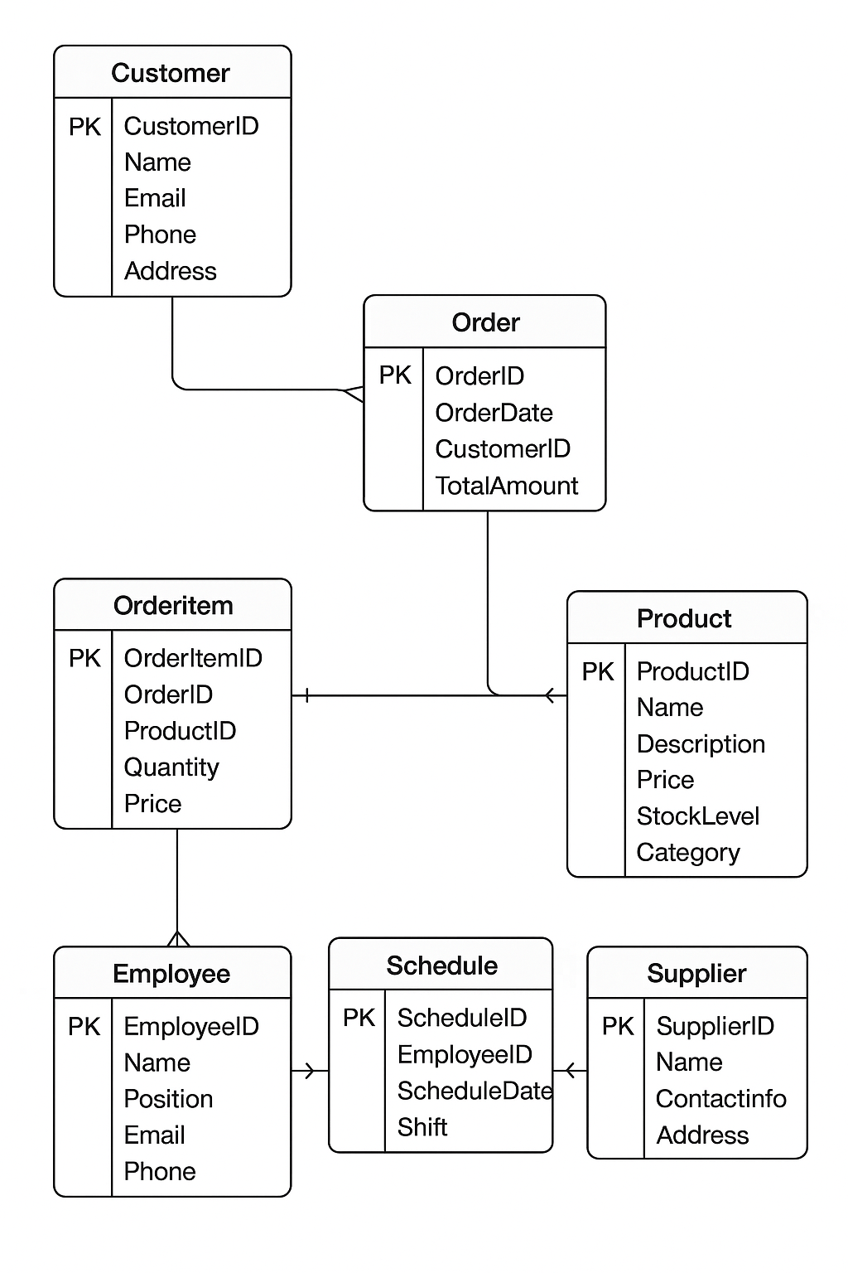
- Create an empty Database. Through an SQL script, implement database tables according to the design presented in the ER Model (Task #1). Make suitable assumptions for any missing requirements and write them down in your hand-in; and paste the script contents to the pdf report.

CREATE DATABASE IF NOT EXISTS NordicX;
USE StoreManagement;

CREATE TABLE Customer (
CustomerID INT AUTO_INCREMENT PRIMARY KEY,
Name VARCHAR(100) NOT NULL,
Email VARCHAR(100) UNIQUE NOT NULL,
Phone VARCHAR(20),
Address VARCHAR(255)
);
CREATE TABLE Supplier (
SupplierID INT AUTO_INCREMENT PRIMARY KEY,
Name VARCHAR(100) NOT NULL,
ContactInfo VARCHAR(150),
Address VARCHAR(255)
);

CREATE TABLE Product (
ProductID INT AUTO_INCREMENT PRIMARY KEY,
Name VARCHAR(100) NOT NULL,
Description TEXT,
Price DECIMAL(10,2) NOT NULL,
StockLevel INT DEFAULT 0,
Category VARCHAR(50),
SupplierID INT,
FOREIGN KEY (SupplierID) REFERENCES Supplier(SupplierID)
);

CREATE TABLE Order (
OrderID INT AUTO_INCREMENT PRIMARY KEY,
OrderDate DATE NOT NULL,
CustomerID INT,
TotalAmount DECIMAL(10,2),
FOREIGN KEY (CustomerID) REFERENCES Customer(CustomerID)
);

CREATE TABLE OrderItem (
OrderItemID INT AUTO_INCREMENT PRIMARY KEY,
OrderID INT,
ProductID INT,
Quantity INT NOT NULL,
Price DECIMAL(10,2) NOT NULL,
FOREIGN KEY (OrderID) REFERENCES `Order`(OrderID),
FOREIGN KEY (ProductID) REFERENCES Product(ProductID)
);
CREATE TABLE Employee (
EmployeeID INT AUTO_INCREMENT PRIMARY KEY,
Name VARCHAR(100) NOT NULL,
Position VARCHAR(50),
Email VARCHAR(100) UNIQUE,
Phone VARCHAR(20)
);
CREATE TABLE Schedule (
ScheduleID INT AUTO_INCREMENT PRIMARY KEY,
EmployeeID INT,
ScheduleDate DATE NOT NULL,
Shift VARCHAR(50),
FOREIGN KEY (EmployeeID) REFERENCES Employee(EmployeeID)
);

- Through an SQL script, create records in each Table according to the case description. If you have a table were the case or logic doesn’t specify the amount of data needed, add 10 or more rows. Paste the script contents to the pdf report.

USE NordicX;
INSERT INTO Customer (Name, Email, Phone, Address) VALUES ('Alice Johnson', 'alice.johnson@example.com', '555-1234', '12 Elm Street'), ('Bob Smith', 'bob.smith@example.com', '555-2345', '34 Oak Avenue'), ('Carla White', 'carla.white@example.com', '555-3456', '56 Pine Road'), ('David Brown', 'david.brown@example.com', '555-4567', '78 Cedar Lane'), ('Eva Green', 'eva.green@example.com', '555-5678', '90 Birch Street'), ('Frank Adams', 'frank.adams@example.com', '555-6789', '23 Maple Avenue'), ('Grace Lee', 'grace.lee@example.com', '555-7890', '45 Walnut Street'), ('Henry Clark', 'henry.clark@example.com', '555-8901', '67 Cherry Blvd'), ('Irene Fox', 'irene.fox@example.com', '555-9012', '89 Spruce Court'), ('Jack Davis', 'jack.davis@example.com', '555-0123', '11 Aspen Way');

INSERT INTO Supplier (Name, ContactInfo, Address) VALUES ('TechSource Ltd', 'techsource@example.com', '101 Industrial Park'), ('FreshFoods Inc', 'freshfoods@example.com', '202 Market Street'), ('HomeEssentials', 'homeessentials@example.com', '303 Supply Road'), ('OfficePro Supplies', 'officepro@example.com', '404 Business Blvd'), ('GadgetWorks', 'gadgetworks@example.com', '505 Tech Avenue'), ('StyleWear Co', 'stylewear@example.com', '606 Fashion Street'), ('AutoParts Hub', 'autoparts@example.com', '707 Mechanic Road'), ('EcoSolutions', 'eco@example.com', '808 Greenway'), ('FurnitureWorld', 'furniture@example.com', '909 Comfort Lane'), ('BrightElectronics', 'brightelectronics@example.com', '100 Tech Blvd');

INSERT INTO Product (Name, Description, Price, StockLevel, Category, SupplierID) VALUES ('Laptop', '15-inch laptop with 16GB RAM', 999.99, 50, 'Electronics', 1), ('Wireless Mouse', 'Ergonomic mouse', 29.99, 200, 'Accessories', 1), ('Office Chair', 'Adjustable swivel chair', 149.99, 80, 'Furniture', 9), ('T-Shirt', 'Cotton t-shirt, size M', 19.99, 300, 'Clothing', 6), ('Printer', 'All-in-one laser printer', 249.99, 40, 'Office', 4), ('Desk Lamp', 'LED desk lamp', 39.99, 150, 'Home', 3), ('Organic Apples', '1kg pack', 4.99, 100, 'Grocery', 2), ('Car Battery', '12V car battery', 129.99, 30, 'Automotive', 7), ('Bluetooth Speaker', 'Portable mini speaker', 59.99, 120, 'Electronics', 10), ('Recycled Paper Pack', '500 sheets A4', 7.99, 400, 'Office', 4);

INSERT INTO Employee (Name, Position, Email, Phone) VALUES ('John Miller', 'Manager', 'john.miller@example.com', '555-1111'), ('Sara Wilson', 'Sales Rep', 'sara.wilson@example.com', '555-2222'), ('Tom Hanks', 'Warehouse Staff', 'tom.hanks@example.com', '555-3333'), ('Linda Carter', 'HR Officer', 'linda.carter@example.com', '555-4444'), ('George Hill', 'Technician', 'george.hill@example.com', '555-5555'), ('Nina Lopez', 'Cashier', 'nina.lopez@example.com', '555-6666'), ('Peter Gray', 'Delivery Driver', 'peter.gray@example.com', '555-7777'), ('Olivia Stone', 'Marketing', 'olivia.stone@example.com', '555-8888'), ('Kevin Reed', 'Accountant', 'kevin.reed@example.com', '555-9999'), ('Rachel Evans', 'Customer Support', 'rachel.evans@example.com', '555-0000');

INSERT INTO Schedule (EmployeeID, ScheduleDate, Shift) VALUES (1, '2025-10-01', 'Morning'), (2, '2025-10-01', 'Evening'), (3, '2025-10-02', 'Morning'), (4, '2025-10-02', 'Evening'), (5, '2025-10-03', 'Morning'), (6, '2025-10-03', 'Evening'), (7, '2025-10-04', 'Morning'), (8, '2025-10-04', 'Evening'), (9, '2025-10-05', 'Morning'), (10, '2025-10-05', 'Evening');

INSERT INTO Order (OrderDate, CustomerID, TotalAmount) VALUES ('2025-09-25', 1, 200.00), ('2025-09-26', 2, 59.98), ('2025-09-27', 3, 129.99), ('2025-09-27', 4, 999.99), ('2025-09-28', 5, 279.98), ('2025-09-29', 6, 39.99), ('2025-09-29', 7, 19.99), ('2025-09-30', 8, 7.99), ('2025-09-30', 9, 149.99), ('2025-10-01', 10, 59.99);

INSERT INTO OrderItem (OrderID, ProductID, Quantity, Price) VALUES (1, 2, 2, 29.99), (2, 10, 2, 7.99), (3, 8, 1, 129.99), (4, 1, 1, 999.99), (5, 5, 1, 249.99), (5, 6, 1, 39.99), (6, 7, 8, 4.99), (7, 4, 1, 19.99), (8, 9, 1, 59.99), (9, 3, 1, 149.99);

Part 2: Write SQL queries to retrieve from your database.
- List customers who have made a purchase within range of dates.

SELECT DISTINCT c.CustomerID, c.Name, c.Email
FROM Customer c
JOIN `Order` o ON c.CustomerID = o.CustomerID
WHERE o.OrderDate BETWEEN '2025-09-25' AND '2025-09-28';

- Find all products with stock levels below a certain threshold.
For example, taking 50 as a threshold value would look:

SELECT ProductID, Name, StockLevel, Category
FROM Product
WHERE StockLevel < 50;

- Retrieve the work schedule for a specific employee for a given within range of dates.

SELECT e.EmployeeID,
e.Name AS EmployeeName,
s.ScheduleDate,
s.Shift
FROM Schedule s
JOIN Employee e ON s.EmployeeID = e.EmployeeID
WHERE e.Name = 'John Miller'
AND s.ScheduleDate BETWEEN '2025-09-30' AND '2025-10-07'
ORDER BY s.ScheduleDate;

- Calculate total sales for each product category in a specific period.
SELECT
p.Category,
SUM(oi.Quantity * oi.Price) AS TotalSales
FROM OrderItem oi
JOIN Product p ON oi.ProductID = p.ProductID
JOIN `Order` o ON oi.OrderID = o.OrderID
WHERE o.OrderDate BETWEEN '2025-09-25' AND '2025-09-30'
GROUP BY p.Category
ORDER BY TotalSales DESC;

- Retrieve all suppliers along with their contact information and the products they supply.
SELECT s.SupplierID, s.Name AS SupplierName, s.ContactInfo, p.Name AS ProductName
FROM Supplier s
LEFT JOIN Product p ON s.SupplierID = p.SupplierID;

- Create a view displaying the purchase history of a specific customer, including dates and amounts spent.
CREATE VIEW CustomerPurchaseHistory AS
SELECT c.CustomerID, c.Name AS CustomerName, o.OrderID, o.OrderDate, o.TotalAmount
FROM Customer c
JOIN `Order` o ON c.CustomerID = o.CustomerID
ORDER BY c.CustomerID, o.OrderDate;

SELECT * FROM CustomerPurchaseHistory
WHERE CustomerName = 'Alice Johnson';

- Create three queries where you select information that you find interesting to retrieve from the case. Try to create queries that are a good representation of your level of understanding of SQL. In other words, you decide the level of complexity/difficulty for the queries.
SELECT Name AS ProductName, Category, StockLevel
FROM Product
WHERE StockLevel > 100
ORDER BY StockLevel ASC;

Part 3: Write a reflection report.
- Write a paragraph or two explaining your database design choices and explain why you think your database tables are in a good, normalized form.
The database design follows a relational structure based on clear entities and their relationships as defined in the ER model. Each table represents a distinct real-world entity - such as Customer, Product, Order, Employee, and Supplier - with attributes specific to that entity. The relationships between these tables are established using foreign keys to maintain referential integrity. For example, each Order record references a single Customer, each OrderItem connects Orders and Products, and each Product is linked to a Supplier. This design allows efficient data organization, retrieval, and management while avoiding redundancy.

- Choose two of the four ACID properties for a DBMS and describe how these two properties affect the use of your database.

Two important ACID properties that affect this database are Atomicity and Consistency.

Atomicity ensures that each transaction is all-or-nothing - either every step succeeds or none do. In this database, that means when a customer places an order, the creation of records in Order and OrderItem, along with updates to product stock levels, must all succeed together. If one action fails, the entire transaction rolls back. This prevents issues such as recording an order without its items or incorrect stock counts.

Consistency guarantees that each transaction keeps the database valid and follows all defined rules and relationships. For example, an Order must always reference an existing Customer, and a Product must have a valid Supplier. This ensures data integrity and prevents invalid or conflicting entries. Together, atomicity and consistency make transactions reliable, maintaining accurate and stable records even with many users.

- Would It be a good idea to use a NoSQL database instead of a relational database for this case? Provide your explanation using one or two paragraphs. You can use examples and/or arguments to prove your opinion.

A NoSQL database wouldn’t be ideal for this case because the data is highly structured and relies on relationships between entities like Customers, Orders, and Products. Relational databases handle these dependencies efficiently with foreign keys and joins, ensuring consistency and integrity that document-based or key-value NoSQL systems lack.
- Prepare a script for a 7-minute video presentation explaining your ER model, the retrieval queries, and their results (≈500 words). Example script can be to introduce your project and goal, describe key entities and relationships in your ER model, explain one or two SQL queries with their results, and conclude by summarizing your database’s purpose.

Hello, in this presentation I’ll explain my database project. The goal is to manage customers, orders, products, employees, and suppliers efficiently. More explanation on each of the entities and their attributes goes here … The ER model defines key relationships- for example, each customer can place many orders, and each order contains multiple items. Using SQL queries, I can retrieve customer order histories or check product stock levels. Overall, this relational database ensures accurate, consistent business data management …

- Using your script provided above (Task #14), create a video that demonstrates the content step by step. Ensure that the video clearly follows the script and shows actions and results. Once completed, save and submit the video as a separate file. Additionally, in your report under Task #15, confirm whether the video has been submitted or indicate if it has not been submitted.

7-minutte video submitted!

